CIS 1111 Programming Topic 7 – Horse Stable
(20 Points)

Description:
In this assignment, you will develop a C++ program to determine if a horse is overweight or underweight, given the type of horse. Once the determination has been made, calculate how much you should feed the horse given their weight.
Use the table below to write a program which prompts the user to enter the type of horse and its weight. The program will display whether the horse is underweight, optimal weight, or overweight and how much to feed the horse.
Type of Horse | Minimum optimum weight range in pounds | Maximum of optimum weight range in pounds
Light riding horse | 840 | 1200
Large riding horse | 1,100 | 1,300
Draft horse | 1,500 | 2,200

How many pounds of food to feed the horse given their weight status:
Underweight | Optimum | Overweight
3.3 | 3.0 | 2.5

Requirements:
- Use variable names that are descriptive and initialized.
- Use an if-else statement for the determination of weight status given the type of horse and how much to feed the horse.
- Verify that the user has entered the type of horse correctly.
- The output must be labelled and easy to read as shown in the sample outputs included in this document.
- Your program must be documented with the following:
  - // Name
  - // Date
  - // Program Name
  - // Description

Submit:
Zipped folder named LastNameFirstNameCIS1111NameOfAssignment which contains:
- Your .cpp file
- Screen shots of your code and output

Sample Output:
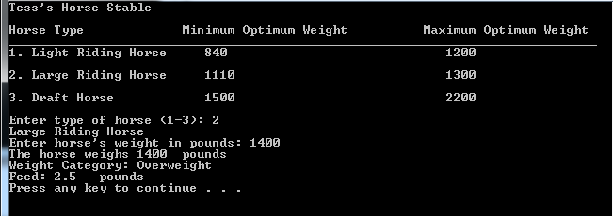

Grading Guidelines for This Assignment
 | Range – Low End  (Did not do or did very little effort) | Range – High End  (Used correctly and spent time/effort on programming)
Names of variables are meaningful and the program comments self-document the program | 0 | 2
Met all stated requirements | 0 | 10
Output is correct given the input, and the output is correctly formatted | 0 | 4
Program compiles and executes without any runtime, syntax, or logic errors | 0 | 3
The zipped project folder that includes the C++ .cpp source files and screens shots of the code and console is uploaded to drop box. | 0 | 1
Total Points Possible | 0 | 20

